MODULE 4 – INTRODUCTION TO DBMS

LAB EXERCISES

10. Data Query Language – DQL
Lab 1.
Write a query to retrieve all books with price between $50 and $100.
Ans.
1. SELECT * FROM books WHERE price BETWEEN 50 AND 100;
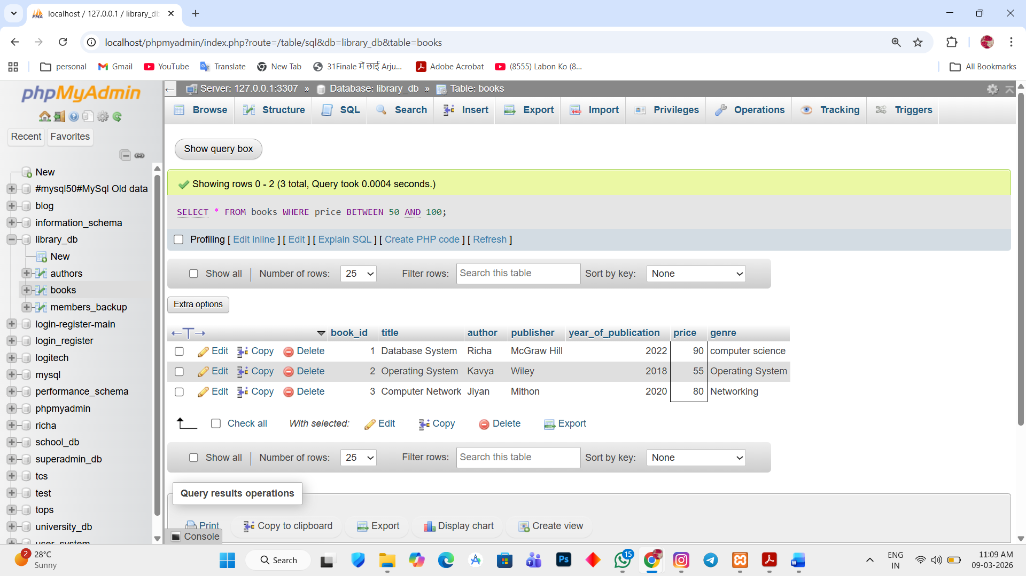

Lab 2.
Retrieve the list of books sorted by author in ascending order and limit the results to the top 3 entries.
Ans.
1. SELECT * FROM books ORDER BY author ASC LIMIT 3;

